Assignment 4

**Question 1: (*Individual Question*)**

Consider a datagram network using 32-bit host addresses. Suppose a router has four links,

numbered 0 through 3, and packets are to be forwarded to the link interfaces as follows:

|  |  |
| --- | --- |
| Destination Address Range | Link Interface |
| 11110100 00000000 00000000 00000000  through  11110100 00011111 11111111 11111111 | 0 |
| 11110100 00100000 00000000 00000000  through  11110100 00100000 01111111 11111111 | 1 |
| 11110100 00100000 10000000 00000000  through  11110100 10111111 11111111 11111111 | 2 |
| otherwise | 3 |

1. Provide a forwarding table that has five entries, uses longest prefix matching, and

forwards packets to the correct link interfaces.

2. Describe how your forwarding table determines the appropriate link interface for

datagrams with destination addresses:

a) 11100100 10010001 01010001 01010101

b) 11110100 10100000 11000011 00111100

c) 11110100 11000000 00010001 01110111

d) 11110100 10000011 11000001 00101100

**Question 2: (*Individual Question*)**

Consider the following topology.

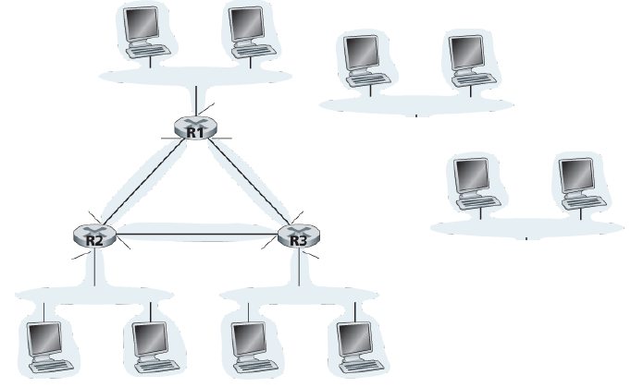

A

B

C

D

E



**4**

a. How many subnets are there in this topology? (240=11110000)

b. Assign network addresses to each of these subnets from their ISP that has the following IP addresses:

218.85.240/20. The IP address assignments should respect the following constraints:

* Subnet A should have enough addresses to support 450 interfaces;
* Subnet B should have enough addresses to support 900 interfaces;
* Subnet C should have enough addresses to support 800 interfaces;
* Subnet D should have enough addresses to support 950 interfaces;
* Subnet E should have enough addresses to support 480 interfaces.
* The remaining subnets should each be able to support two interfaces.

For each subnet, the assignment should take the form a.b.c.d/x **or** (a.b.c.d/x **minus** e.f.g.h/y).